Ideal State
In an ideal state, DICE resource limit will approximately equal how many units are breaking to each sort path per hour. Based on the DICE resource limit set by the site in partnership with central flow, the DICE cost will fluctuate to try to meet the demand requested by the DICE resource limit.
A good example of this working is the data showing before 18:00 for 5# below. DICE resource limit was set at 11,300 with 16 stations. Projected rate should be 706, and 5# hit 709. There are visible fluctuations in DICE cost during that time period that allowed the demand to be met.
Technically, the guidance is to set DICE to 110% of plan because some percentage of the units will get redirected to mansort at UIS, and because the SOP is downstack WIP to give sort teams a lever to pull during fluctuations later. With downstacking, it is critical that sort teams should know immediately if their designated downstacking area becomes full.
Fluctuations
In present state, fluctuations are inevitable for a couple of reasons. First, there is baked in reaction time to the cost adjustments, where the system controlling DICE Cost needs some period of time to determine that the cost needs to be adjusted.
Additionally, DICE Resource Limit and DICE Cost are bounded. This is due to a tradeoff between ITS decision making and DICE/Flow decision making. Our ability to manipulate the flow to feed stations is restricted to not be able to force outcomes that are detrimental to the business (based on ITS’s assessment of the case/unit and the “network” justification for sorting).
Looking at the DICE Resource Limit and DICE Cost after 18:00, you can see an example of this. Towards the start of shift, 5# cost has not hit it’s lower bound. From 18:30-23:00, 5# ran an average of 20 stations at a 751 rate. Based on DICE Resource limit of 18,000, they were actually asking for 900 units/station/hour. DICE Cost ended up hitting the floor around 1am, at which point adjusting DICE Resource Limit would not result in more work being directed to 5#. From 01:00-03:00, 5# rate averaged 560.
Even without hitting the cost bounds, it is known that ITS can overassign or underassign significantly relative to the expected rate based on the resource limit if the ITS cost factors are strong enough (sites have identified that throttling or reducing parcel trailers is their number one lever for forcing overassignment or underassignment).
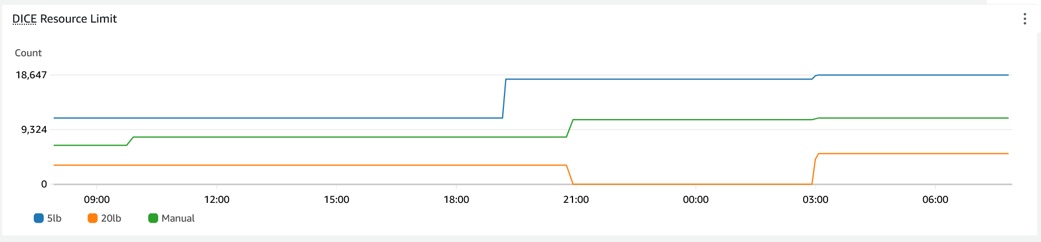
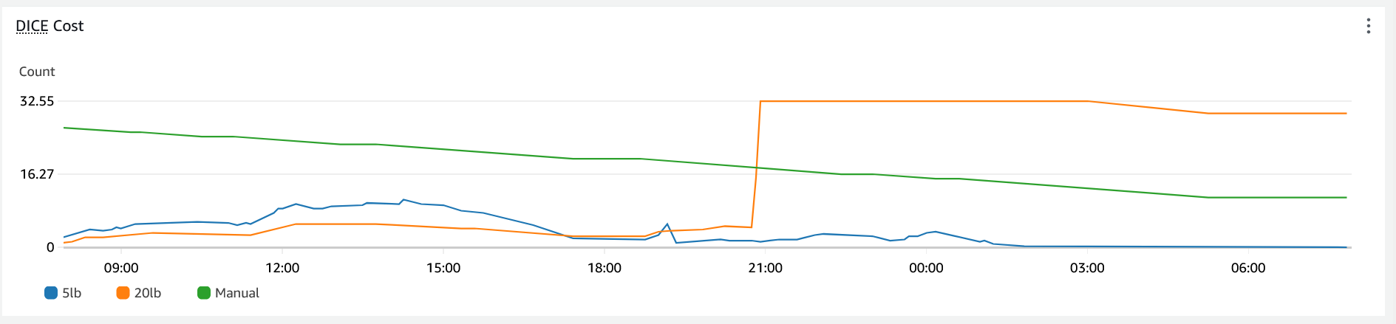
AutoDICE
One insight that is applicable to more or less all Gen 4.3 IXD is that UIS flow is suboptimal and this results in decreased rates. To take the guess work out of projecting rates, AutoDICE is designed to automatically throttle Resource Limit in response to Photo Eye Fullness and Sorter Utilization for each respective sort path.
At this time, it is known that AutoDICE V1 does not optimally flow sites that Decant, and AutoDICE V2 is in development to improve this.

Recommendations
- Establish a baseline rate target for the site and assign at 110% to target. (Present state)
- Set a target number of parcel trailers to be throwing at any given time based on the rate that they are arriving on site (when yard is not empty).
- Expect overassignment or underassignment, especially if case density is fluctuating from inbound dock. Adjust dice in the following manner below and standardize a plan for returning to baseline (either between shifts or end of week). If overassignment or underassignment is persistent with a stable mix, adjust baseline value.
- Reach out to Central Flow to adjust dice up as soon as sort needs to start processing downstack WIP due to lack of work AND there is no known MHE issue. Downstack IOL?
- Reach out to Central Flow to adjust dice down when designated downstack area is full.
- Request reduced sort headcount when DICE Cost is zero and that sort path is experiencing starvation.
- Report overassignment when DICE Cost is at a ceiling and recircing.
- Both Flow and Sort teams should be utilizing this dockflow page to roughly gauge if dice needs to be adjusted to meet sort demand. It is based on photo-eye fullness and carrier utilization.
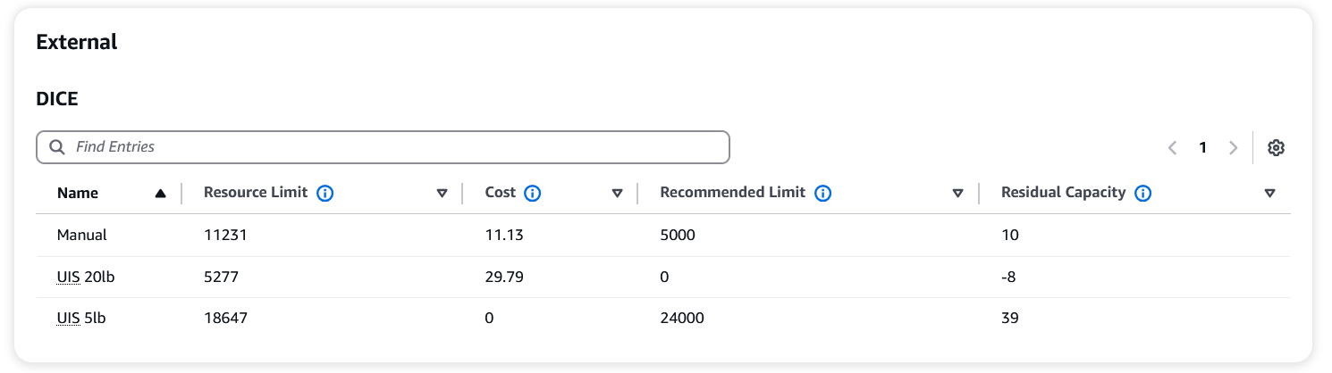
Advanced Recommendation
If a site has the mix to support it (large number of parcel trailers in backlog), they can ramp parcel unloading and expect overassignment. Then they can reduce DICE Resource Limit, which will increase DICE cost and ITS will only send the best containers to sort – which will yield the highest rates. Overassignment can be beneficial in this way assuming all four corners run the same mix to allow for consistent performance. The easiest way to control this is to closely monitor the number of parcel appointments being added per shift and the actual number of units breaking relative to DICE Resource Limit.

